# **Entering Data in Excel:**

When we enter data to use in JASP, we want to follow the “tidy data” rule. Tidy data is:

* Each person gets their own row of data.
* Each column is a different variable for the data.

To create data, we can start typing in Column A, Row 1. Let’s create a dataset of men and women with scores on a variable (Loves Cats).

In the first **row**, type the name of the variables:

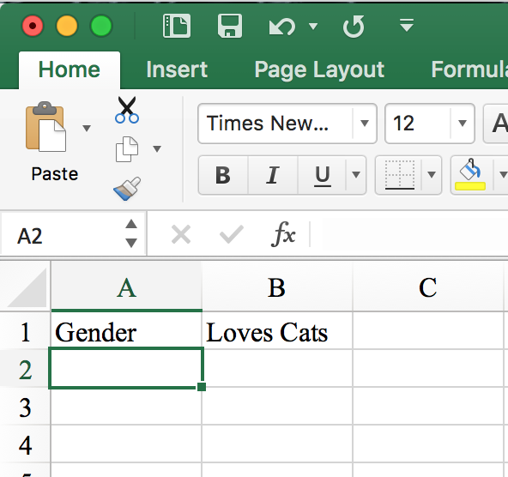

JASP will understand that the first row of the dataset is the name of each variable.

Starting in the second **row**, add some data for the participants.

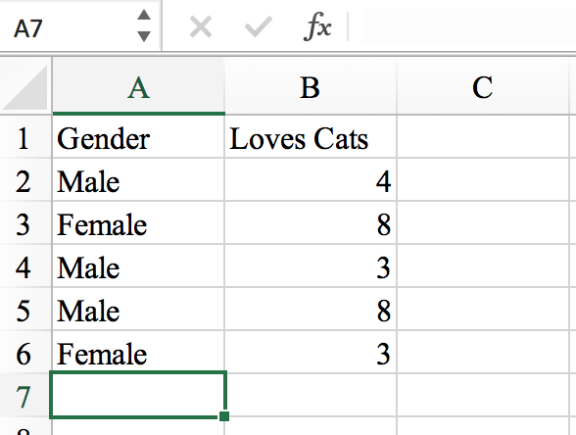

JASP will interpret the second **row** as the start of the data points (or each participant in your dataset). This dataset would be considered “tidy” because each person is a specific row (Male participant who rated Loves Cats as 4, Female participant who rated Loves Cats as 8, etc.) AND each column is a different variable (Gender and Loves Cats).

It’s very tempting to type in the data more like this:

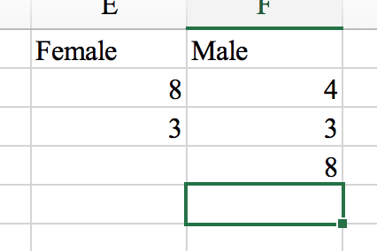

As a person starting to learn statistics and data, this organization does seem logical. However, it can be confusing for statistics programs to interpret if you have several variables for each gender (i.e., you also asked them about Loves Dogs).

If you want to use your Excel file in JASP, you will need to save it as a **.csv** file. Normal excel files are **.xsl or .xslx** but you will want to pick **Comma Separated Values.** There are a couple options, but use the one with no other special indicators (i.e., UTF-8).

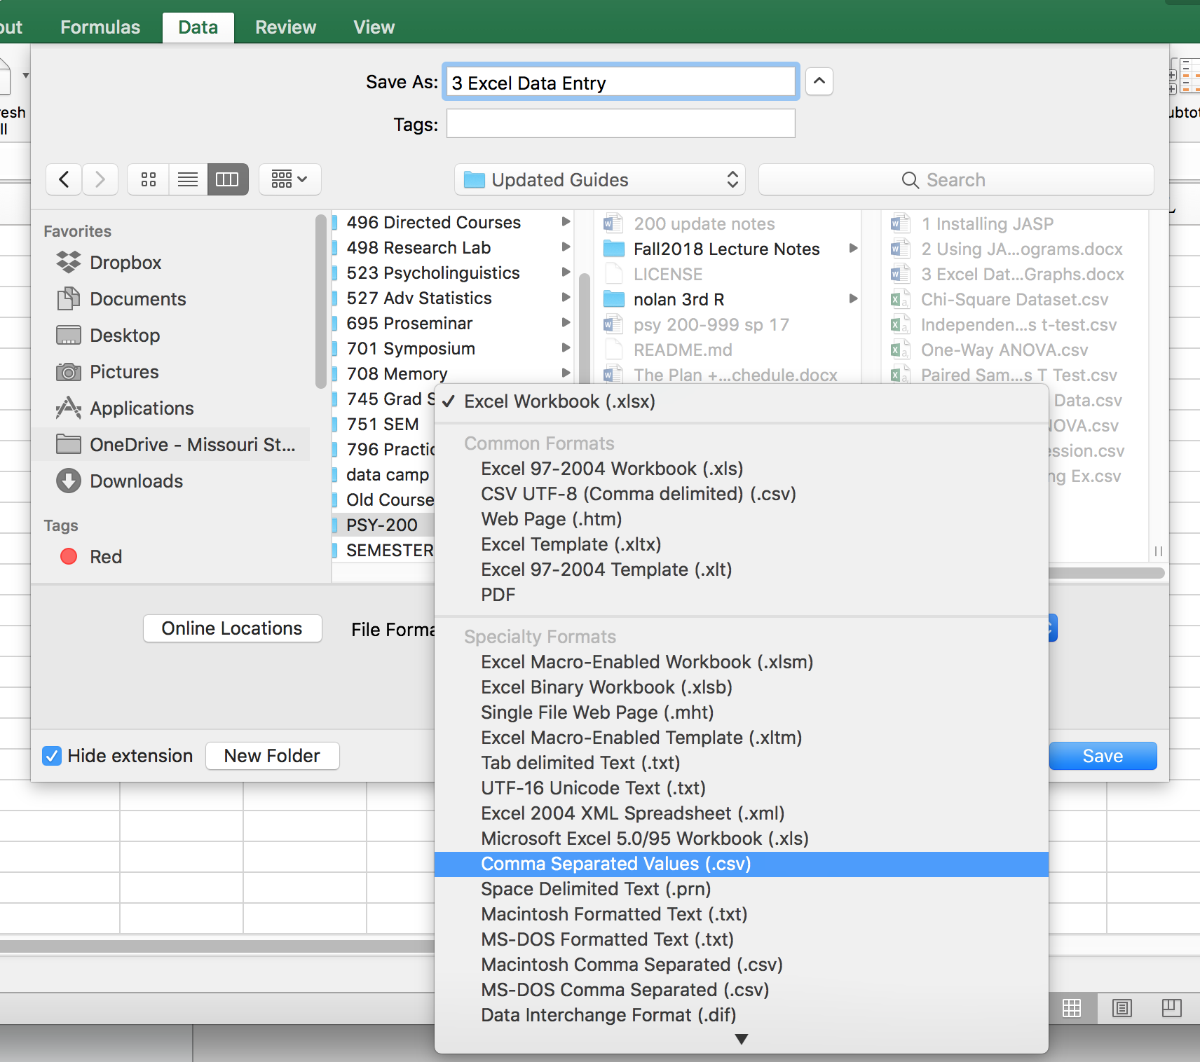

You will likely see this window as well:

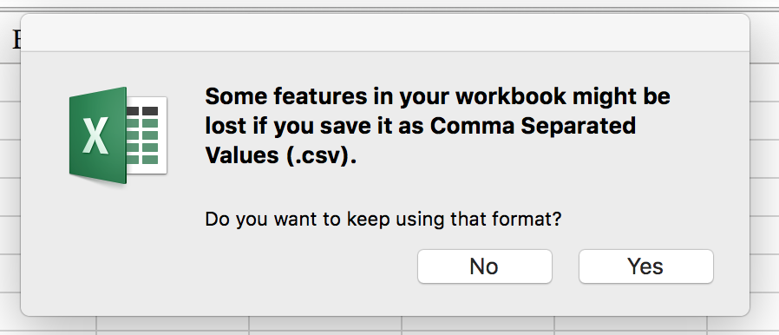

Click “yes”.

# **Editing Data in JASP:**

To open a data file click “File” 🡪 “Computer” 🡪 “Browse” and select the file from your computer.

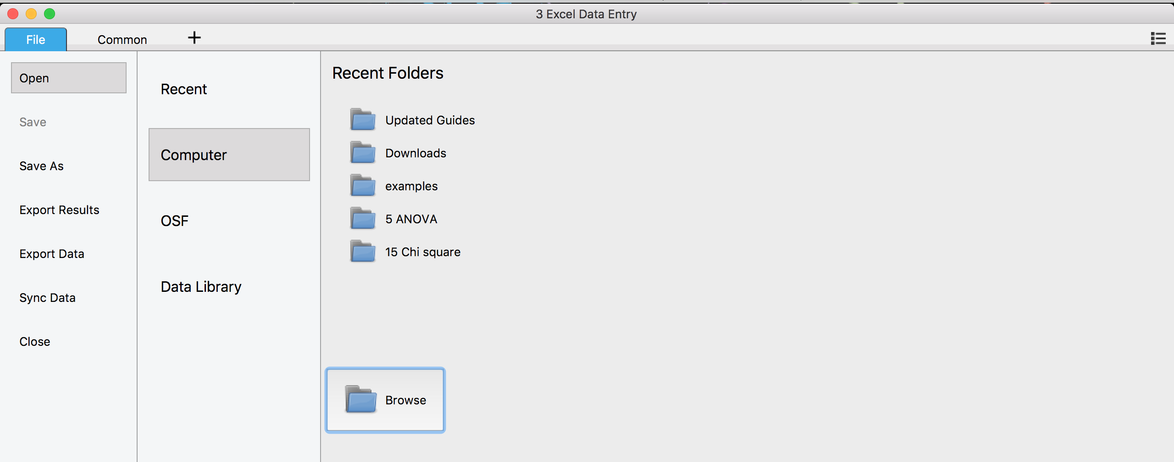

We have now opened the .csv excel file we made above in the example.

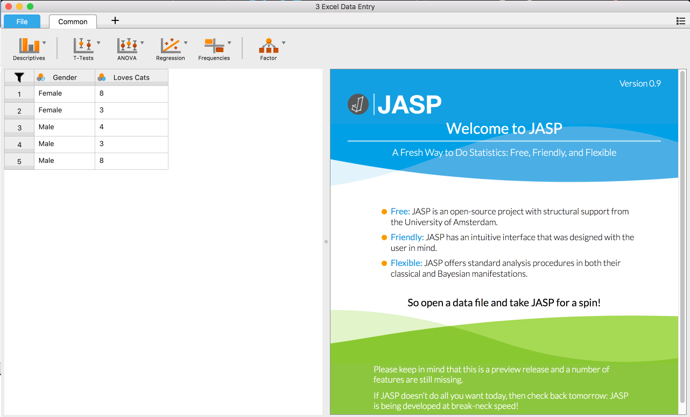

If you want to edit the data found in JASP, double click on a cell of the data. After you double click, Excel will open, and you can edit like we did in excel earlier. I added two more lines of data.

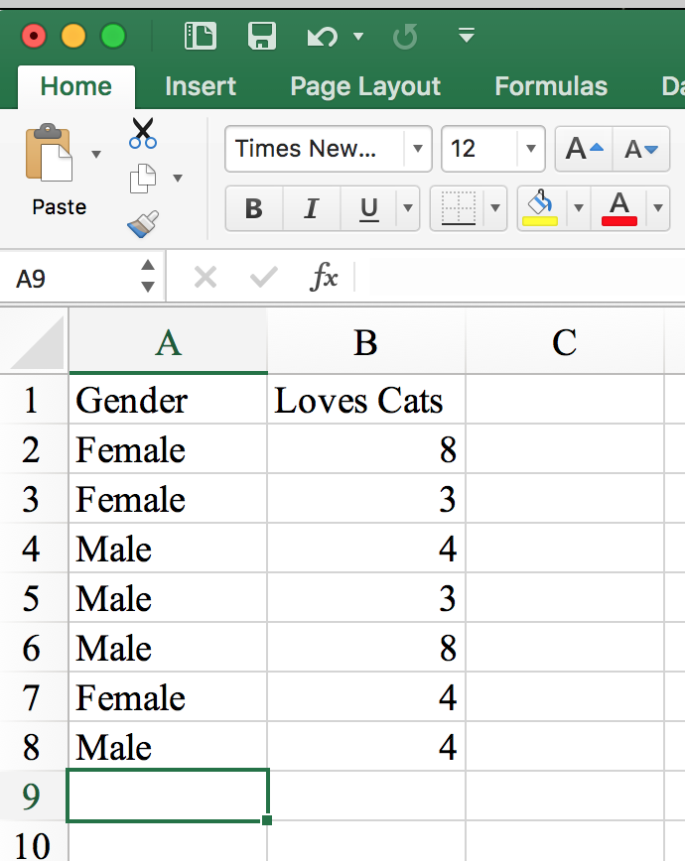

Now, save your data in Excel by clicking the “Save” icon  or by using “File” 🡪 “Save”. When you switch back to JASP, you will see the updated data.

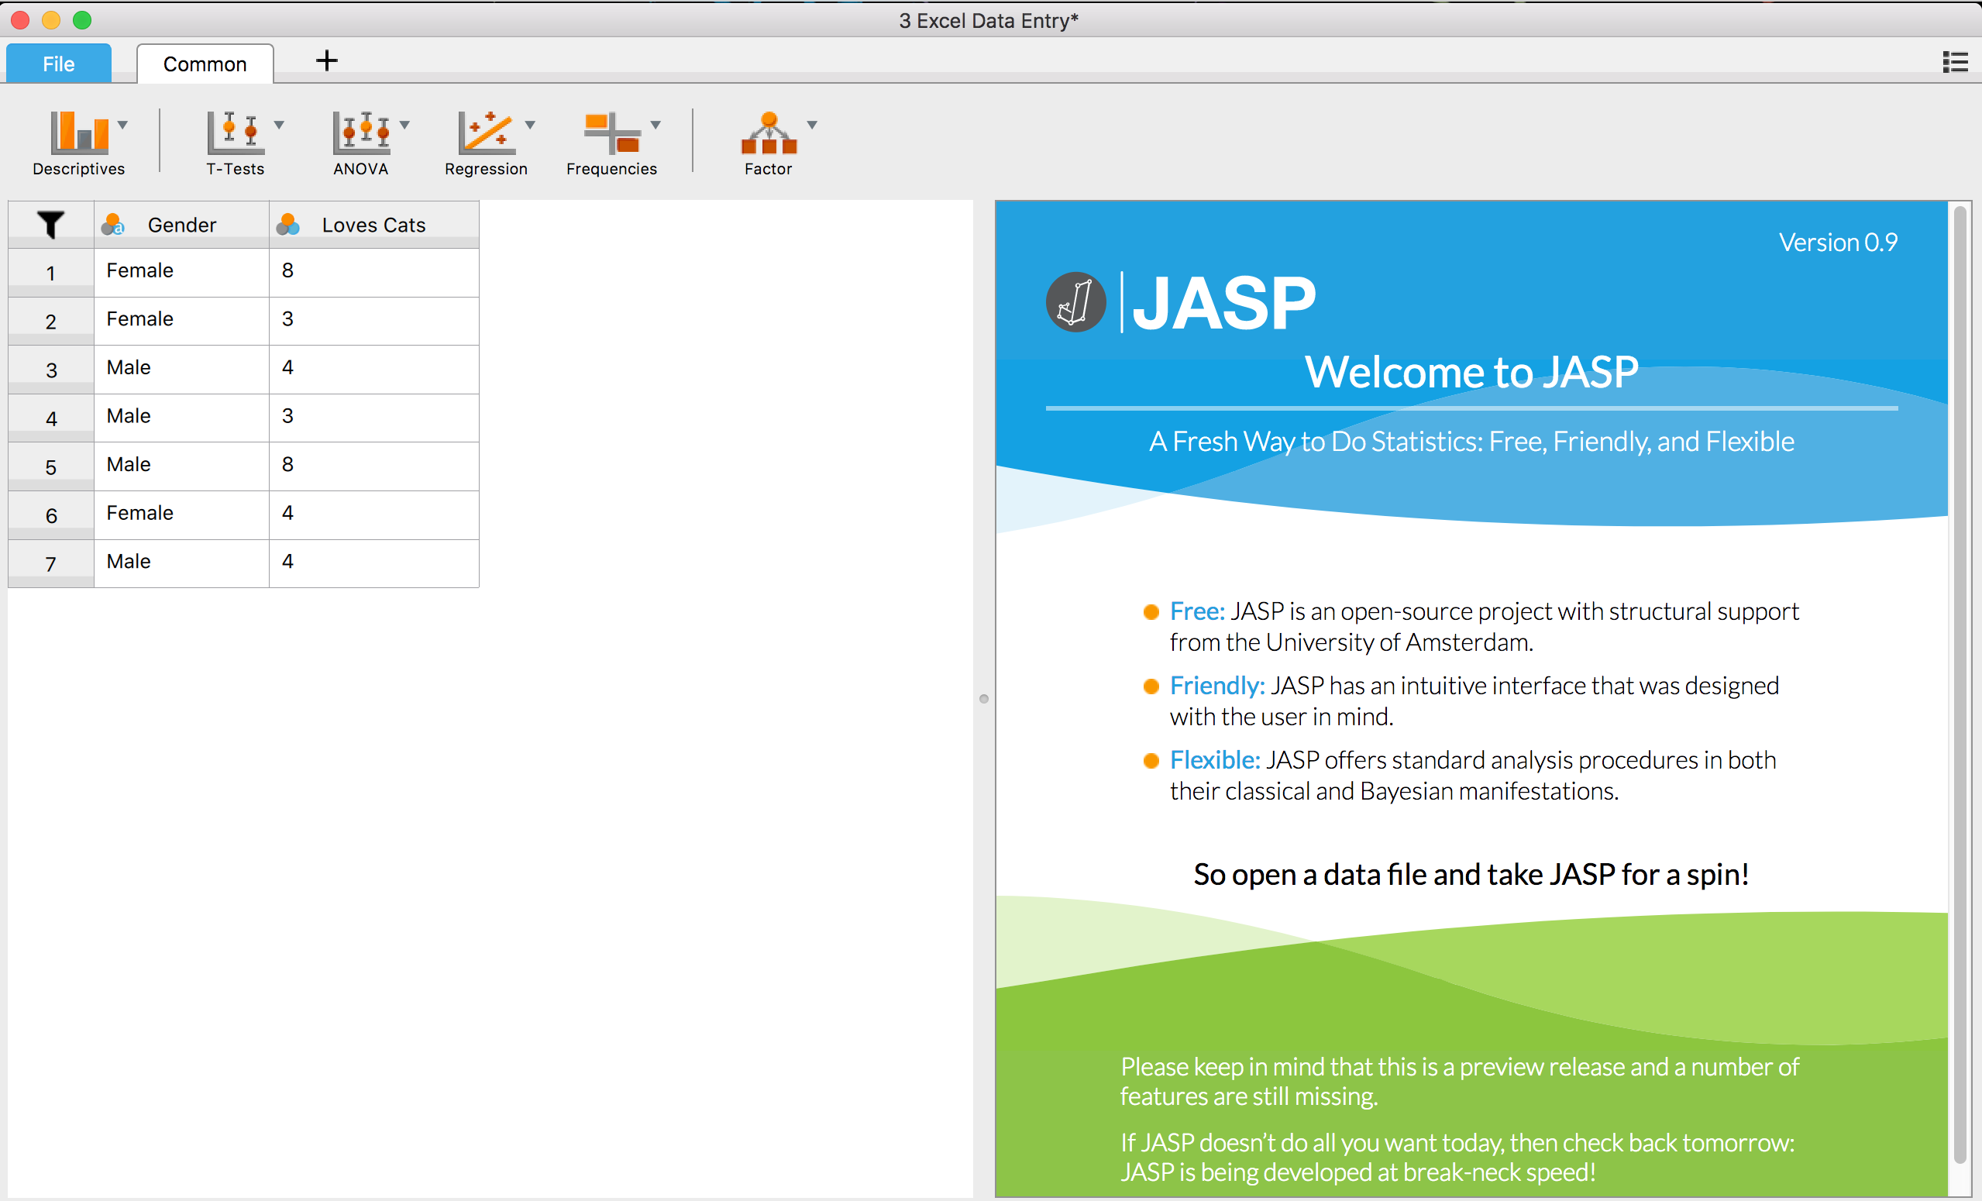

If you are using a built in dataset for JASP, they don’t want you to edit their original data. If you double click on that data, you will see the following box:

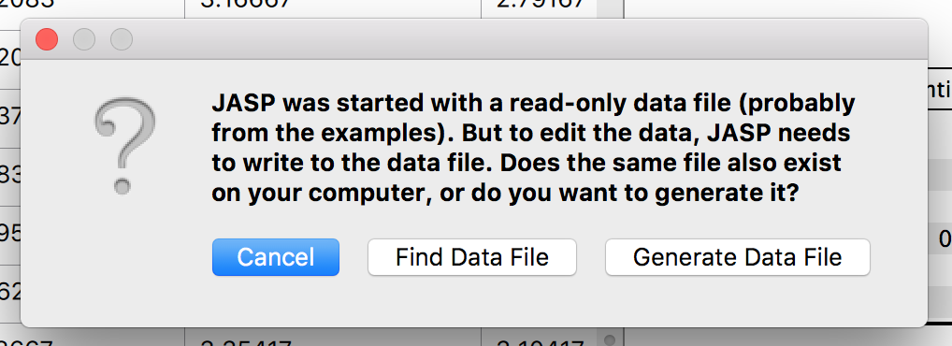

If you want to edit that dataset, use “Generate Data File” to create a version of it you can edit in Excel.

# **Creating Graphs in Excel:**

In JASP, you can create graphs based on the analysis options you picked, but they often don’t contain all the information you might want (and you can’t edit them directly). This section will cover how to make graphs in Excel so you can control all the parts of the graph yourself.

### Bar or Line Graphs:

One Independent Variable:

First, you need to enter the data you want to graph, which is usually the means of each group. You can put this information in any cells you like in Excel.

Second, you will want to enter any secondary data that you want to graph, which is often the standard deviation or standard error of the means (depends on your instructor!) to make the error bars that you might see on a bar or line graph. Here’s an example below, and the error bars are the lines on each bar, which denotes the variation around the mean.

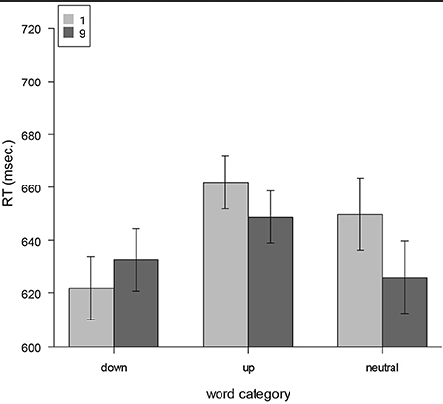

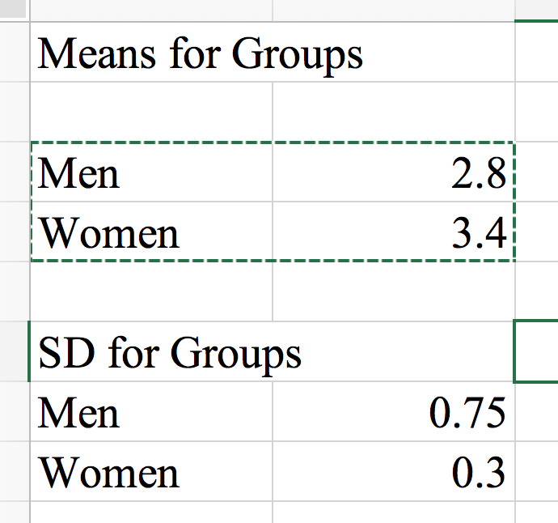

After you enter the data, highlight it, and click “Insert” tab in the top excel menu 🡪 click either “2D column” or “2D line” to get a bar graph (called columns) or line graph. The instructions are the same for them after this point.

To get the bar graph you would click this icon:

Insert Tab

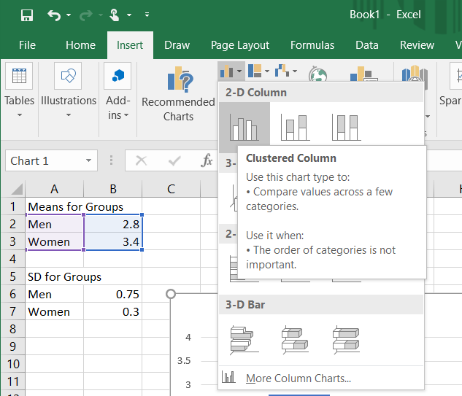

Bar Graph

To get the line graph you would click this icon:

Insert Tab

Line Graph

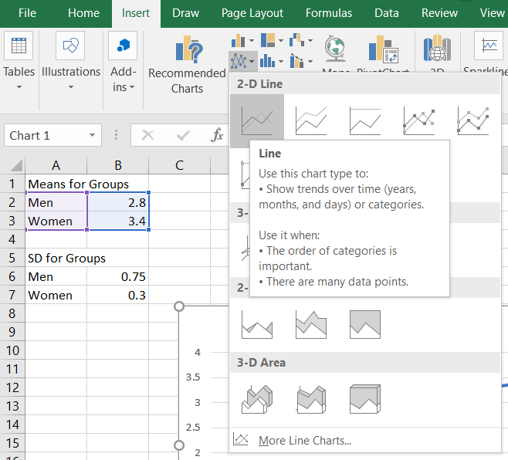

If you select the bar graph, this is the graph you will get to start with:

The first chart you get is pretty bland. You will want to delete the “Chart Title” as that is not included in APA style. To do this, you can simply click on the words “Chart Title,” and click delete on your keyboard, or you can also click on the graph and then the  icon in the “Design” tab, click “Chart Title” 🡪 “None”.

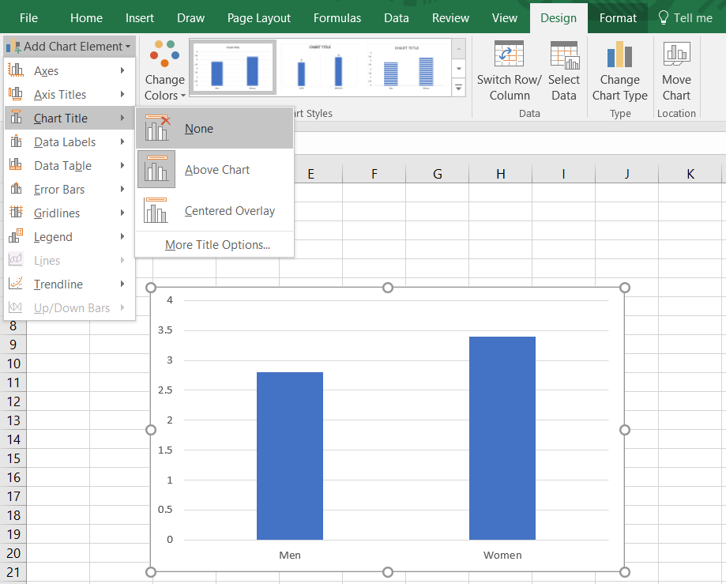

There are lots of options to clean up the graphs, but here are some of the most popular ones:

Change the font by clicking on the words (men/women on the X-Axis) or numbers (Y-Axis) on the graph, and changing the font under “Home” tab on the top Excel menu.

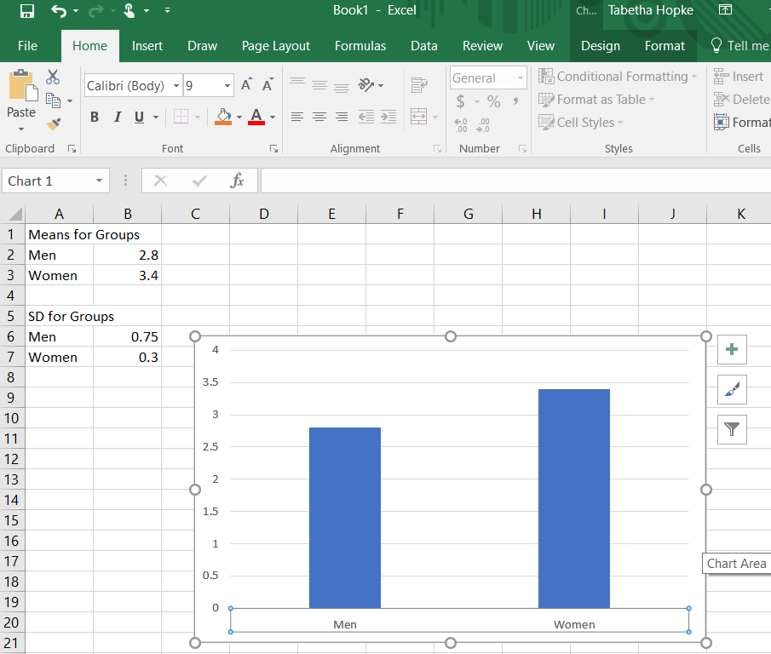

Click here to change the x-axis font

Click here to change the y-axis font

Home Tab

Change the color by **double** clicking on the bars of the graph, which will pull up a side menu. Click on the paint icon at the top  🡪 “Fill” 🡪 “Solid Fill” 🡪 and then pick a color by clicking the paint icon next to “Color.” 

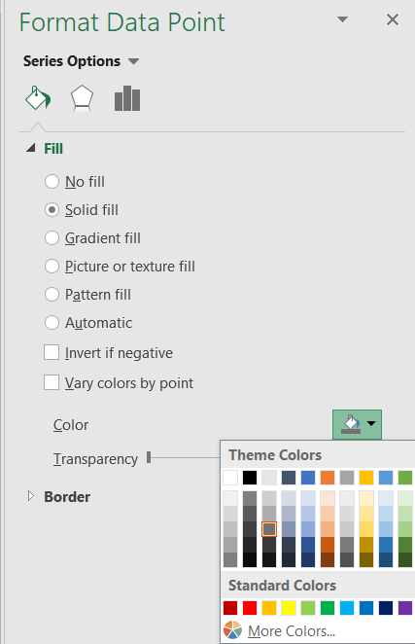

Add X and Y axis labels by clicking on the graph and then the  icon in the “Design” tab. From there click “Axis Titles” and select “Primary Horizontal”, then repeat and select “Primary Vertical.”

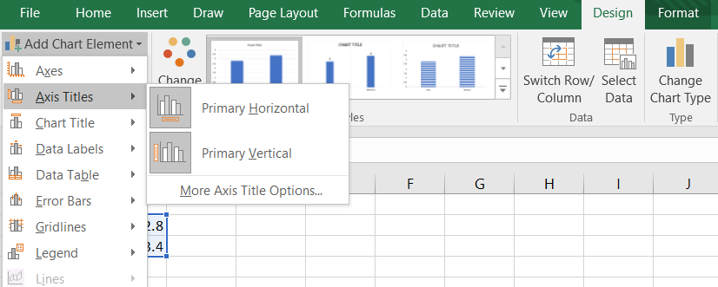

To edit these titles, click on the words “Axis Title”, select the words, and type over it with your variable name.

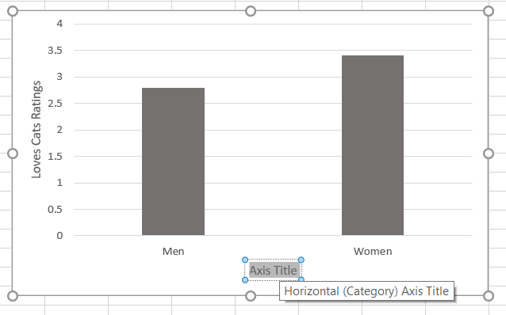

To add error bars, start by clicking on the graph and then on the  icon in the “Design” tab. From there click the arrow to the right of “Error Bars” 🡪 “More Error Bar Options…”

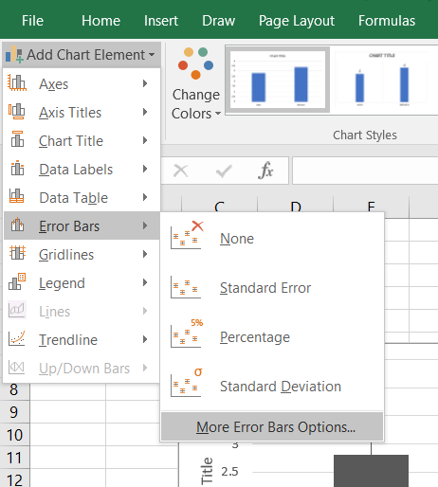

A side menu for “Format Error Bars” will open up.

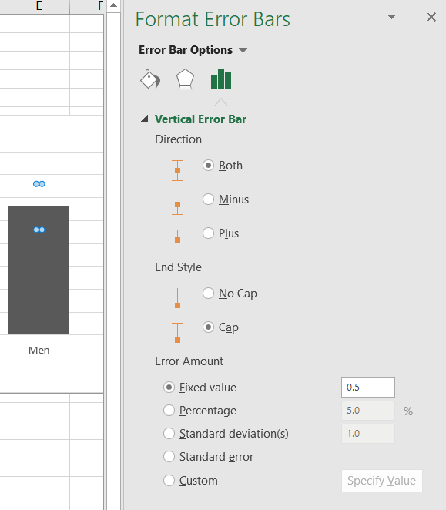

Click “Custom” 🡪 “Specify Value” 

A new window will pop up allowing you to select the area you put in the standard deviation or standard error. Be careful here to highlight the right cells, as well as the same cells for both “Positive” and “Negative” Error values.

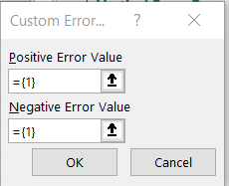

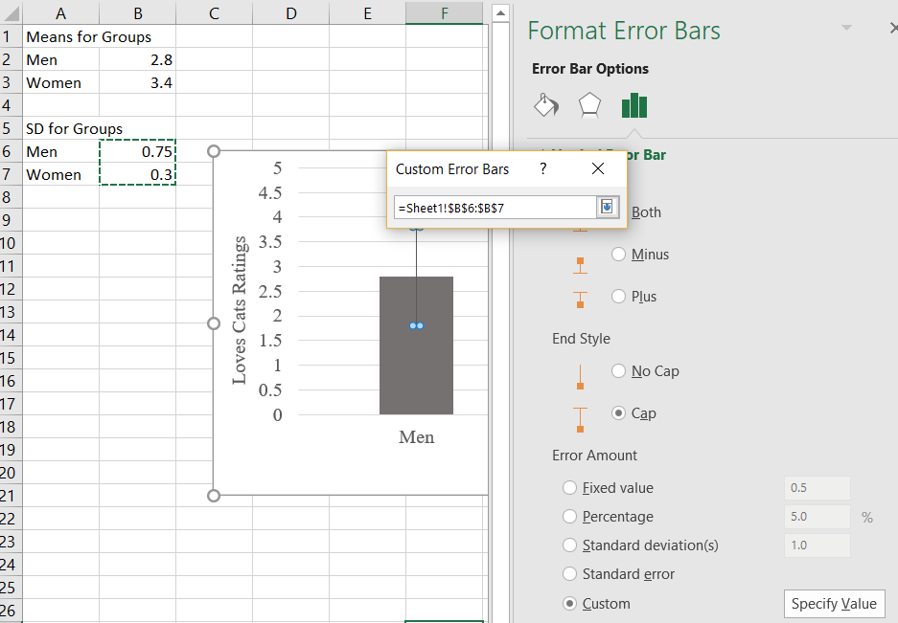

After you highlight the cells for the SDs, it should look like this below with numbers and codes (may be different cells on your screen):

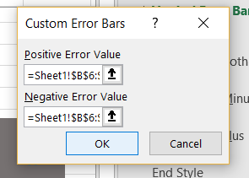

Click “Ok” and the bars will be added to your graph!

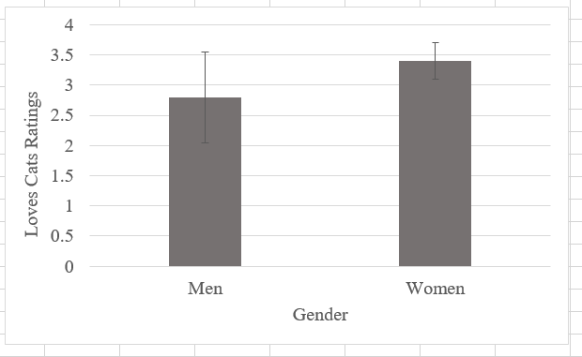

### Scatter Plots:

Two Independent Variables:

The data entry for scatter plots require that you have all the points, not just the means for each group, so you will start by entering the data points.

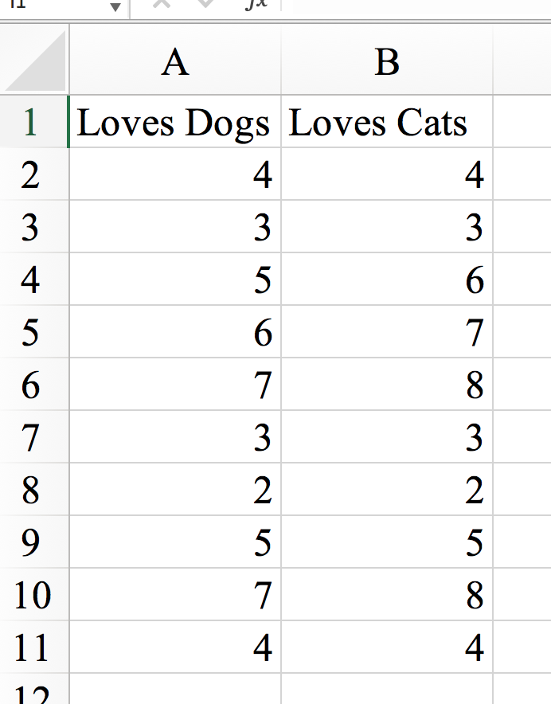

Highlight all the data (including the variable names). Then, click on “Insert” 🡪 “Scatter” 🡪 and select the first scatter plot option.

Insert Tab

Scatter Plot

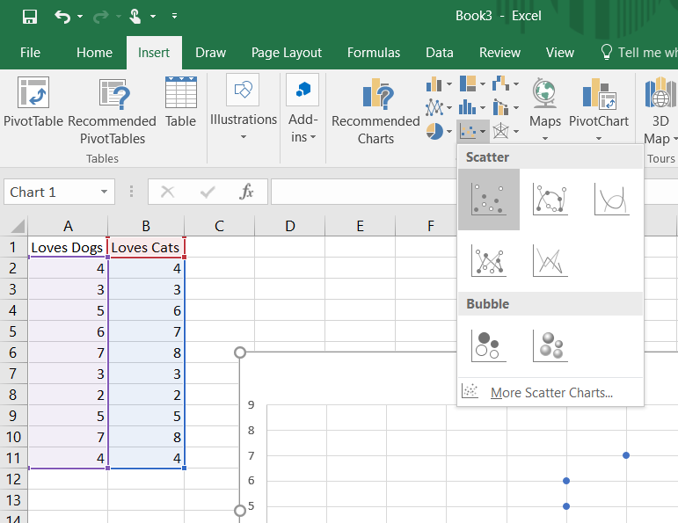

This is what it will give you to start with:

Again, pretty bland to start with, but you can edit a bunch of things:

You will want to delete the chart title as that is not included in APA style. To do this, you can simply click on the title that it assigned and then click delete on your keyboard, or you can also click on the graph and then the  icon in the “Design” tab, click “Chart Title” 🡪 “None”.

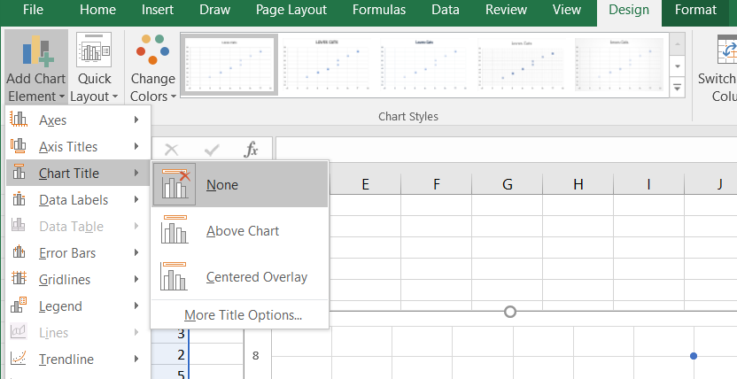

You can change the font by clicking on the numbers in the x- and y-axes and changing the font under “Home” tab on the top Excel menu.

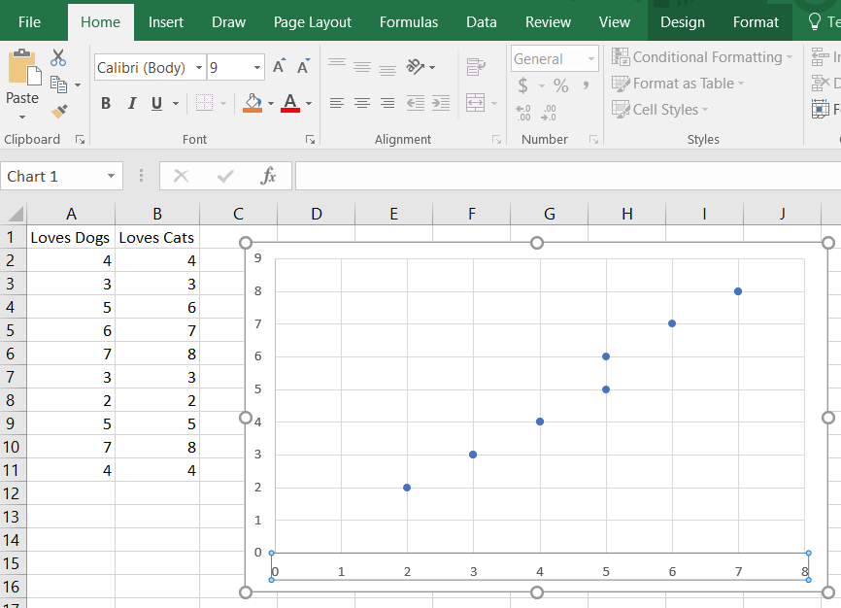

Click here to change the y-axis font

Click here to change the x-axis font

Home Tab

Add X and Y axis labels by clicking on the graph and then  icon in the “Design” tab. From there click “Axis Titles” and select “Primary Horizontal”, then repeat and select “Primary Vertical.”

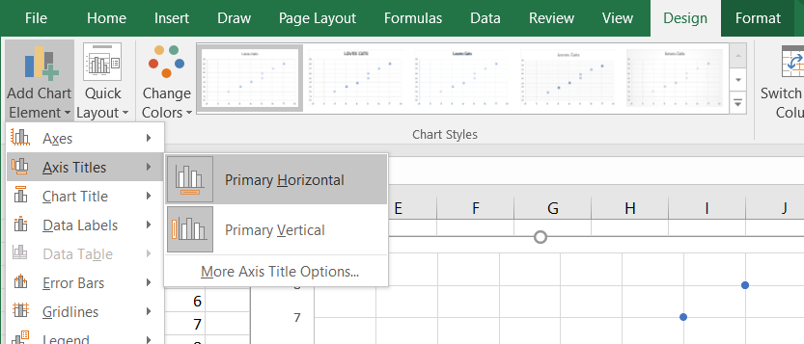

To edit these titles, click on the words “Axis Title”, select the words, and type over it with your variable name.

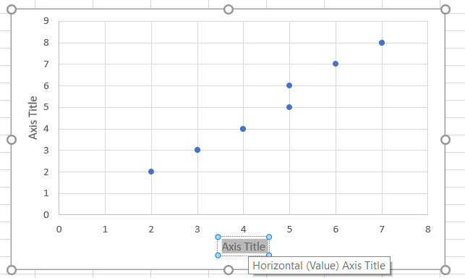

Change the color by **double** clicking on one of the dots on the graph, which will pull up a side menu. Click on the paint icon at the top  🡪 “Marker” 🡪 “Fill” 🡪 “Solid Fill” 🡪 and then pick a color by clicking the paint icon next to “Color.” 

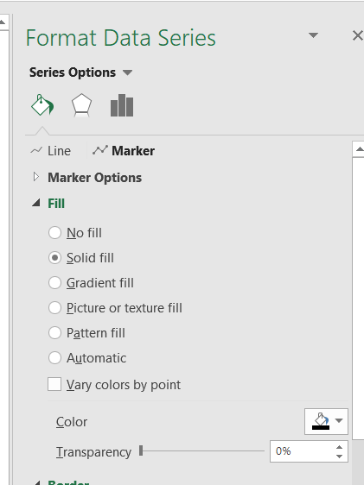

Additionally, you can add a “line of best fit”. To do that, click on the graph and then  icon in the “Design” tab. From there click “Trendline”, and then select whichever option you need. “Linear” is usually the option you will want.

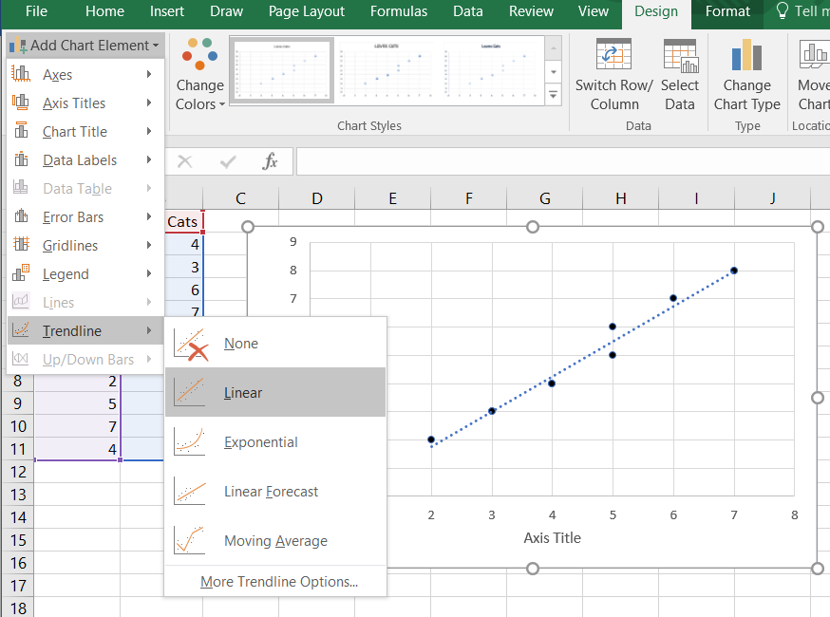

If you double click on the line you added, if will pull up another side menu where you can add other components as well. For instance, you can add the equation of the line to the graph by selecting the option to “Display Equation on Chart” or add the R2 value by selecting the option to “Display R-squared value on chart” if your instructor wants either of these on your graph.

